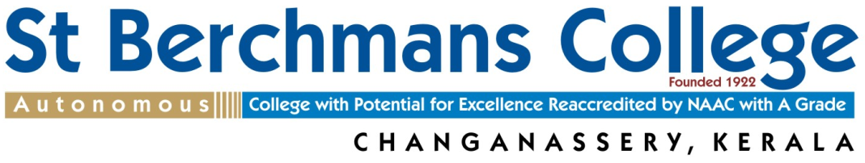
Affiliated to Mahatma Gandhi University, Kottayam, Kerala.
Tel: +91 9447249214 Fax: 0481-2401472
E-mail: berchmansaward@sbcollege.ac.in Web: www.sbcollege.ac.in
BERCHMANS AWARD 2021

Affix Photograph
AWARDED BY: ST BERCHMANS COLLEGE
INSTITUTED BY: ALUMNI ASSOCIATION OF
ST BERCHMANS COLLEGE (AASBCO)
KUWAIT CHAPTER, P B NO. 3986
SAFAT-13039 STATE OF KUWAIT
PRO FORMA
Name of the Teacher
(in block letters)
Designation
Department, College, University
Gender, Marital Status
Age and Date of Birth
EDUCATIONAL QUALIFICATIONS
Sl No | Name of the Course |  |  | Year of Passing |  | Subject |  |  | University |  | Marks  (%) | Rank
1
2
3
4
5
6
7
Date of entry into service
Date of retirement
Total teaching experience in years/months
Sl No |  | Names of the Colleges served (including guest lectureship, FDP positions etc) |  |  | Period of Service |  |  |  |  | Name of the University
1
2
3
4
5
Official Address:  Pincode: |  |  |  |  |  |  |  | Home Address:  Pincode:
Phone No with STD Code: |  |  |  |  |  |  |  | Mobile No:
E-mail id:
Academic achievements (after entry in service)
Details of published books, Research papers, Major/Minor projects, Fellowships etc
- Best ten papers, Best five books/book chapters, Collaborations, Funds generated, Patents*

Papers/Courses designed and introduced.
Have you ever served any institution outside Kerala/India?
If so, give details:

What are the innovative methods you adopt in teaching, learning and evaluation?
Give details:

Do you serve as a Research Guide? If yes, give the details and no of Ph D and M.Phil Theses you have produced

Have you served in the following capacities? If yes, please indicate the periods of service and other relevant details.
- College Union Advisor
- College Arts Club Advisor/President
- Chief Editor, College Magazine
- Asst. Supdt. of College Examinations
- Returning Officer, College Union Election
- Programme Officer, National Service Scheme
- Commanding Officer, NCC
- In Charge of Guidance and Counselling
- Director of various Clubs, Associations etc
- President/Secretary, Staff Association
- Member, College Staff Council
- Member, College Governing Council
- Role in College Sports and Games, Specify:
- Role in spiritual activities
- Any other service
Please give details of your significant contributions in any of the above mentioned areas:

Have you conducted remedial programme for weak students and/or enrichment programme for advanced learners?
Give details:

Positions holding/held outside the Campus (include memberships in professional bodies/organisations)

Have you been a member of University statutory bodies? Give details:

Have you served as a Resource person in Workshops, Seminars, Refresher Courses etc? Give details:

Have you written any articles in Newspapers or Periodicals? Give details:

Present details of Membership in editorial boards of academic journals and/or details of work done as a reviewer for academic journals.
Have you received any Fellowships or Awards before? Give details:

Detaiils of training programmes/ workshops/ conferences/ seminars organized at the State, National and/or International level

Details of involvement in Community Development Activities (Community Outreach Programmes, Extension Activities etc)

Any other relevant information.

I attest that all the records and details furnished above are true
Date:……………………………… Signature:
Principal’s recommendation:

College seal:

- Use separate sheets of paper for any further information.
- Support all your claims with relevant documents
- Please send your pro forma duly filled in to: THE SECRETARY, BERCHMANS AWARD COMMITTEE
ST BERCHMAS COLLEGE, CHANGANACHERRY, KOTTAYAM, KERALA-686101
Last date for submission: 14 February 2022
FOR OFFICE USE ONLY
Date of receiving the Proforma
Details of Screening
Remarks

